TASK 2 – LOAD TEST SCRIPT

1. Please import the maven test project from the following repo

GIT URL : <https://github.com/melwineee/loadTest>

Branch : Master

1. Import the project in Eclipse IDE as maven project (Ensure maven environment variables are already configured in the system where the script is executed)
2. Navigate to the following tree structure to configure the URL, thread count and timeouts for the test

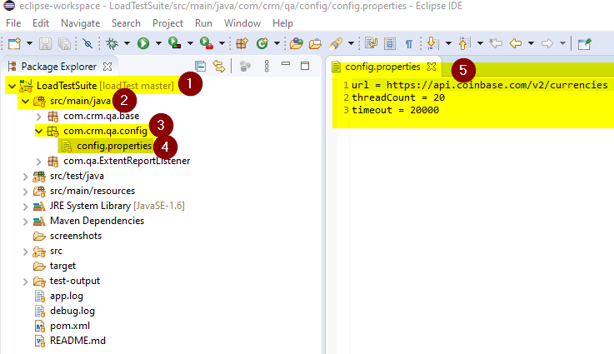

1. Navigate to the TestNG XML file

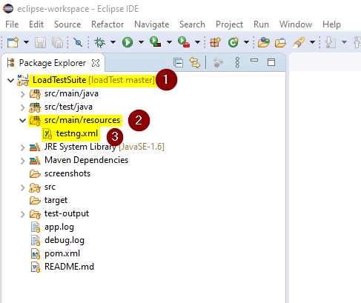

1. Right click on the TestNG XML file and execute it as TestNG Suite

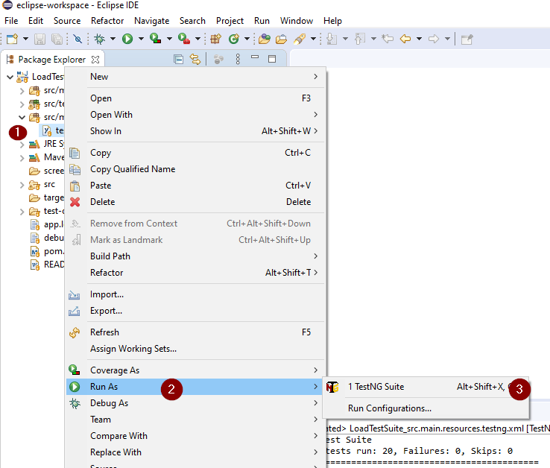

1. After the execution is complete, navigate to the test-output folder to get the excel and extent reports. The load_test.csv has all the execution stats.

